Introduction‘
Learnings from 50 years in the Industry, June2022
Unique Gas Issues or Incidents and Lessons Learned
- Acetylene why is it dangerous to overpack or cap a leak? Why did FDNY pay for a company to fly people and equipment up from Texas to decommission 2 cylinders in Brooklyn?
- Ammonia is a corrosive and a flammable gas. What PPE in an emergency? Responders have been serious injured by not considering the flammability hazard.
- Arsine the Asia Freighter incident had over 10 people acutely exposed, what happened and what was the medical treatment and the lessons learned?
- Arsine incidents which includes a 65 lb release
- Boron trifluoride when released creates a dense white cloud, how to respond? It also does not respond to a mineral acid gas sensor for leak detection like the other acid gases
- Chlorine, the DHS Jack Rabbit releases provide enormous ER information about a significant (20 ton) release. Would a firefighter and a fire engine survive a tsunami wave of chlorine?
- Chlorine trifluoride almost destroyed a 300 mm Fab, what other incidents have happened? An overfilled cylinder ruptured and a operator made a mistake drilling into a cylinder.
- Cryogenic liquid, what happens if you shoot an RPG into a liquid oxygen tank? Machine gun a liquid nitrogen tank? This happened in South America
- Diborane is an unstable gas forming penta and decaborane over time. These are extremely reactive as well as dermal toxins. Pentaborane has been the cause of a worldwide EPA recall. One operator was splashed with it and was paralyzed for a week.
- Disilane forms energetic byproduct in the vacuum pump and vent lines. One company surrounds their vacuum pumps with blast blankets.
- Explosive Gas Mixtures, almost 40 known incidents 1963- 2019 many fatal. Why did they happen? They continue to be a problem
- Fluorine even at 0 psig can react with stainless tubing. To control this problem the pressure is limited to 500 psig in the cylinder
- Gas mixtures made with a liquefied gas can reliquefy during cold temperatures. Will they remix?
- Germane is an unstable gas that ruptured a cylinder in 1984. The controls put in place have prevented at least 3 major incidents
- Hydrogen chloride, why did the 40’ tube trailer explode?
- Hydrogen selenide has been involved in at least 3 incidents where the entire cylinder was released causing multiple acute exposures, what happened?
- Purification of nitrogen trifluoride using a active solid such as mole sieve can be dangerous. Explosions and fire
- Methyl Chloride Route 295 Reefer Explosion, Container full of tangerines explodes
- Nitric oxide becomes shock sensitive at cold temperatures. Explosions during purification
- Nitrous oxide, laughing gas everyone assumes is benign, yet it has been involved in a number of severe explosions.
- Nitrosyl chloride incident
- Phosphine
- Severity of a silane explosion, how much does it take to completely flatten a gas cabinet?
- The Gollub incident in 1988 has been the silane incident with the most severe outcome (3 fatalities and 1 Injury). The chemist that attempted to analyze the cylinder speaks about what happened
- Unusual silane incidents, remove the valve while the cylinder is full! operate a silane supply business from a motel! Corrosion of a cylinder in a heated water bath, silane permeated through the cylinder walls. Overpacking this silane cylinder while the wall is popping and flashing.
- Thermodynamically unstable gases such as acetylene, cyanogen, diborane,, germane, nitrous oxide, incidents and how did we control them in the cylinder?
Packaging
- Cylinder/Valve
- Is it a ASME Pressure Vessel or DOT Cylinder or both?
- What can happen if the cylinder is dropped without a cylinder cap protecting the valve? How about ton cylinders?
- Tube trailers
- Ton Cylinders
- Cylinder fill amount
- Fabrication of the Ngai LIN Tanker
- The Development of a cylinder valve Restrictive Flow Orifices (RFO)
- Cylinder cap
- Why do cylinders fail?
  - Overfill
  - Stress Corrosion, CO or S
  - Explosive mixture
- High Pressure Jumbo Tube Failure
- Subatmospheric gas delivery
- Can a Carbon Steel Cylinder Chilled with Dry Ice Embrittle on Impact?
- Development of a Cylinder Valve Restrictive Flow Orifice
- Development of an Electronic Specialty Gas Valve and Outlet Connection
- Droptesting of cylinders without Cylinder Cap
- Drop a full Y Container from an Forklift from 8 ft
- Fabrication of the Ngai LIN Tanker
- High Pressure Cylinder Failures

Physical Properties
- Adiabatic compression, flow velocity, reduction of diameter, sweep of curve
- Compressibility of a Compressed Gas
- Latent Heat of Vaporization
- Vapor Specific Gravity
- Using Heart Cut for Higher Purity Liquefied MOCVD Gas
- Vapor Pressure of a Liquefied Gas

Regulations/standards
- Hazard Classification
- Toxicity, flammability ISO Standards
- When can the cylinder be labelled “empty”?
- Coaxial Tubing for Silane
- ESM US Standards and Regulations
- Gas Mixture Toxicity Classification
- Ngai to CGA History of P20 and ISO10298 Sept2015
Unique Problems
- Liquefy air
- Teflon tape on valve outlet threads
- Blown pressure gauges
- Some interesting silane incidents

Safety
- Silane Testing
- Cylinder and valve safety
- Metal Hydride Gas Cylinder Leak Check
- Is an “Empty” cylinder hazardous waste?

Gas Systems
- High purity surface preparation
- Passivation
- Purge gas
- Cylinder heaters
- Autogard
Emergency Response
- History of Cylinder Salvage Vessels (ERCV’s) and regulations. What didn’t work in the 1960-70’s?
- Cascade
- Cold Coil Transfer
- Purging cylinder (Huff and Puff, Flow through)
- Cylinder or valve drilling, penetration some interesting learnings
- Flammable or Pyrophoric Gas Fire
- When is the cylinder empty?
Ngai Rules of Thumb
- Leak rate
- Heat transfer
Medical Treatment
- Arsine, Hydrogen Selenide, Germane
- Phosphine
- Diborane
They include:
- What happens if I drop a cylinder onto the valve?
- Air liquefaction has caused a few explosions?
- Why is it not safe to neutralize a spill of hexachlorodisilane?
To prevent future incidents, all gas supplier, users and others must be aware of the following incidents and lessons learned. This is not a comprehensive list it is only ones that I know of. Unfortunately many in my generation have retired without passing along this critical information. I have tried to be as accurate as possible
These are copyrighted, please do not copy and produce a book or training on it without acknowledgement.
Introduction
The specialty gas industry began with Matheson. ¹
The Early Days
The title, "Father of the Specialty Gas Industry," rightfully belongs to Adam Matheson, a chemist who established The Matheson Company in the late 1920s. That company’s first customers were chemistry laboratories, as well as schools, colleges, and universities (lecture halls). The products offered were mainly gas generators (primarily for hydrogen sulfide), to be used in qualitative and quantitative chemistry, and the popular lecture bottles first used during class sessions that demonstrated the properties of a number of common gases.
When Adam Matheson died in the early 1940s, The Matheson Company was acquired by the Ferris family of Hackensack, N.J., with George Ferris (a lawyer) assuming the position of President. His good friends, Dave Ross (accountant) and a later arrival, Cass Heinrich (comptroller), rounded out the executive staff. During World War II, Matheson supplied the U.S. Navy and the Army Air Force with small cylinders of compressed air for use in inflating life rafts. During that period, the Ronson Company invented the butane-fueled cigarette lighter; and Matheson was contracted to manufacture the original filling equipment for those lighters. For a short time, Matheson also filled the lighters until Ronson assumed that operation.
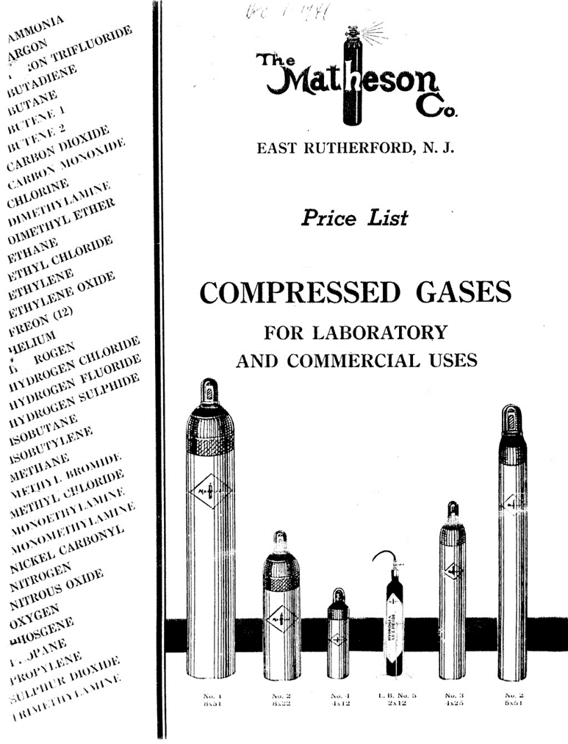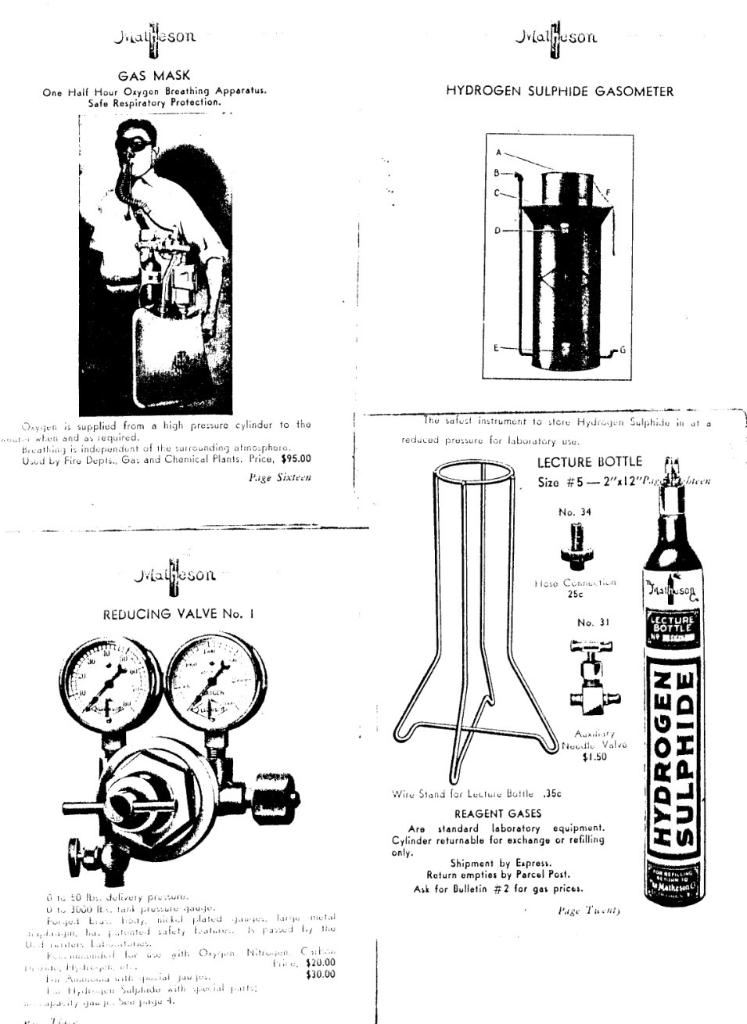
We learned from the first generation, Ezra Erb, Linde, Dave Scott, Air Products, Herb Gill, Precision Gas Products, Frank Olejko, Liquid Carbonic, Al Mossman, Matheson, Robert Sterrett, Matheson Bill Kalaskie, Superior Valve, Felix Smist, Sherwood Valve
The incidents involving silane and fluorine are well known and will not be reported here.
References
- Mossman, A, Remembering Matheson: A pioneer in the Specialty Gas Industry”, 2003 Specialty Gas Reporter, edition unknown
- Ribovich, J., Murphy, J. and Watson, R. “Detonation studies with nitric oxide, nitrous oxide, nitrogen tetroxide, carbon monoxide, and ethylene”,Journal of Hazardous Materials,Volume 1, Issue 4, 1975-1976, Pages 275-287

Eugene Ngai

